SAFETY DATA SHEET

SECTION I - PRODUCT IDENTIFICATION

PRODUCT NAME: CD 4250 PART B PRODUCT CODE: CD4250-B
PRODUCT CLASS: Polyol CAS NUMBER: None
COMPANY NAME: | MANUFACTURED FOR: Coyote Quick Adhesive CD4250 B  419 N. Curtis Rd.  Boise, Idaho, USA 83706  Telephone no.:208-429-0026  www.coyotedesign.com
EMERGENCY ASSISTANCE:
CHEMTREC® (24 hours) U.S. : 1-800-424-9300 International: +1-703-527-388

SECTION II - HAZARDS IDENTIFICATION

Information In accordance with 29 CFR 1910.1200

GHS Classification:

Skin Irritation Category 2
Eye irritation Category 2A
Acute Toxicity Inhalation Category 4

GHS Label elements:
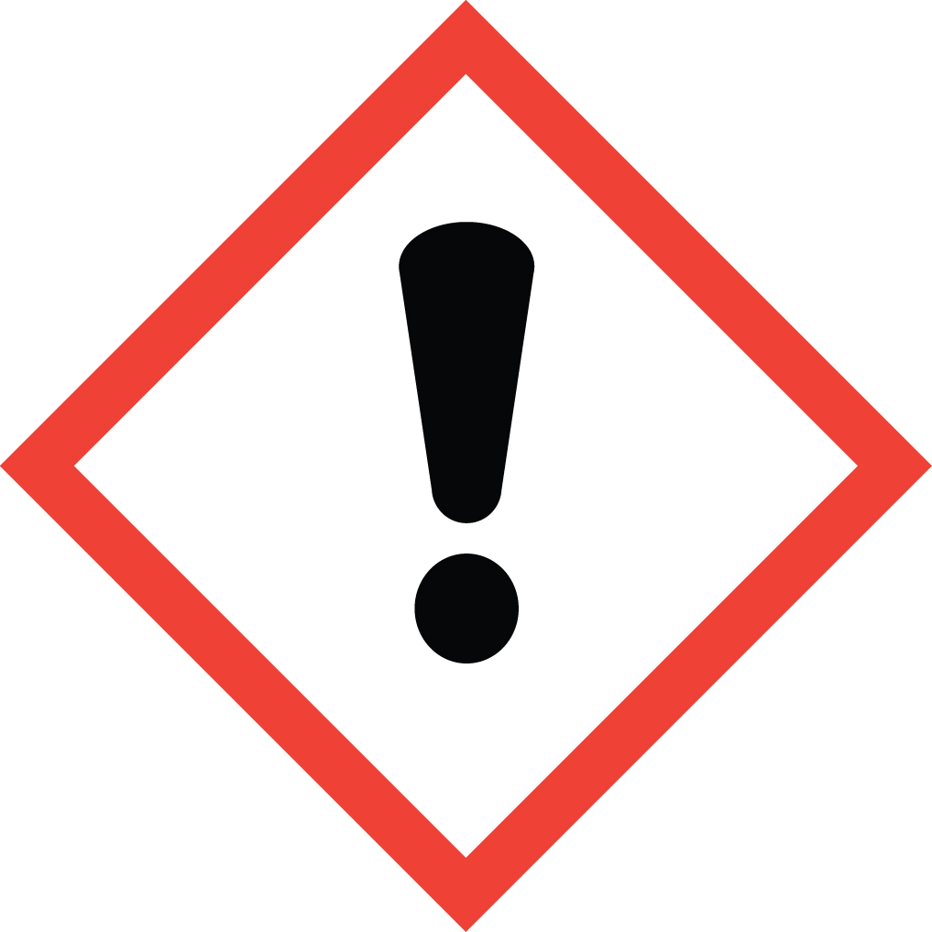
Pictograms

Signal Word: Warning

Hazard Statements:

H315: Causes Skin Irritation
H320: Causes eye irritation
H335: May cause respiratory Irritation

Precautionary Statements:
P261: Do not breathe vapors, mist or spray
P264: Wash thoroughly hands after handling
P280: Wear eye and face protection. Wear protective gloves
P301+P330+P331: If swallowed: Rinse mouth. Do not induce vomiting.
P302+P352: If on Skin: Wash with plenty of soap and water
P305+P351+P388: If in eyes: Rinse cautiously with water for several minutes. Remove contact lenses if present and easy to do so. Continue rinsing.
P332+P313: If skin irritation occurs :Get medical attention
P337+P313: If eye irritation persists: Get medical attention
P342+P311: If experiencing respiratory symptoms: Call a poison center or physician
P404: Store in a well-ventilated place
P232: Protect from moisture
P233: Keep container tightly closed
P501: Dispose of contents and /or container according to Federal State/Provincial and local governmental regulations.

SECTION III - COMPOSITION / INFORMATION ON INGREDIENTS

COMPONENT | CAS NO. | Weight | ACGIH TLV | OSHA PEL
NJTSRN-CD4250-B | -- | -- | -- | --

SECTION IV - FIRST AID MEASURES

SKIN CONTACT : Remove contaminated clothing or shoes, wipe excess from skin and flush with
plenty of water for at least 15 minutes. Use soap if available or follow by washing
with soap and water. Do not reuse clothing until thoroughly cleaned.

EYE CONTACT : Flush eyes with plenty of water for at least 15 minutes while holding eyelids open
and seek medical attention.

INHALATION : Remove victim to fresh air and provide oxygen if breathing is difficult. Give artificial respiration if not breathing and seek medical help immediately.

INGESTION : Do not give any liquids (do not induce vomiting) if victim is unconscious or very drowsy. Get medical help immediately.

SECTION V - FIRE FIGHTING MEASURES

EXTINGUISHING MEDIA: Use Dry Chemical, Carbon Dioxide, Foam or Water Fog

SPECIAL FIRE FIGHTING PROCEDURES AND PRECAUTIONS :

Full emergency equipment with self-contained breathing apparatus and full protective clothing should be worn by fire fighters. Do not enter a confined space without full bunker gear, including a positive pressure NIOSH approved self-contained breathing apparatus. During fire, irritating and toxic gases may be generated by thermal decomposition or combustion.

SECTION VI - ACCIDENTAL RELEASE MEASURES

SPILL OR LEAK PROCEDURES:

Remove all sources of ignition and ventilate the area. Dike and contain spilled material and control further
spillage if feasible. Cover spill with clay, sand, saw dust, vermiculite, Fuller’s earth or other suitable absorbent. Collect material in non-leaking containers and seal tightly for disposal. Refer to section 13 for disposal information.

SECTION VII - HANDLING AND STORAGE

Handle in accordance with good industrial hygiene and safety practices. These practices include avoiding unnecessary exposure and removal of the material from eyes, skin and clothing. Employee education and training in the safe use and handling of this material are required under the OSHA Hazard communication standard. Use with adequate ventilation.

STORAGE: Store indoors in a dry place away from heat, sparks and flame. Keep containers tightly closed when not in use.

SECTION VIII - EXPOSURE CONTROLS / PERSONAL PROTECTION

EYE PROTECTION: Safety glasses, splash goggles

SKIN PROTECTION: Avoid contact with skin and clothing. Use chemical resistant protective gloves.

RESPIRATORY PROTECTION: Avoid breathing vapors which may be produced under some conditions such as heating. Avoid breathing aerosols and mists. Use NIOSH / MSHA approved respiratory protection equipment when airborne exposure is excessive.

VENTILATION : Hazard control from vapor or spray mist is ideally performed by the use of engineering controls. General or local ventilation or isolation may prove adequate to keep airborne exposures below exposure limits.

SECTION IX - PHYSICAL AND CHEMICAL PROPERTIES

PHYSICAL FORM: Liquid
COLOR: Black
BOILING POINT: Not available
SOLUBILITY: Negligible (in water)
WEIGHT PER GALLON: 10.8 pounds
VAPOR DENSITY: Heavier than air
EVAPORATION RATE : Not available
(N-Butyl Acetate)
LIQUID DENSITY: Higher than water
FLASH POINT : >325 °F (PMCC)
FLAMMABILITY LIMITS: UEL % Not established LEL % Not established
AUTO IGNITION TEMP. :Not established

Note: These physical data are typical values based on material tested but may vary from sample to sample. Typical values should not be construed as a guarantee analysis of any specific lot or as specifications for the product.

SECTION X - STABILITY AND REACTIVITY

STABILITY: Product is stable under normal conditions of storage and handling.

CONDITIONS TO AVOID : Moisture and high temperature

HAZARDOUS POLYMERIZATION : Will not occur under normal storage conditions.

DECOMPOSITION PRODUCTS : By heat and fire: Carbon dioxide, carbon monoxide, Aldehydes, acids and other organic substances may be formed.

SECTION XI - TOXICOLOGICAL INFORMATION

Product is not toxic

SECTION XII - ECOLOGICAL INFORMATION

Data not available.

SECTION XIII - DISPOSAL CONSIDERATIONS

Waste must be disposed of in accordance with federal, state and local environmental control regulations. Incineration is the preferred method. Empty containers must be handled with care due to product residue. Do not heat or cut empty containers with electric or gas torch.

SECTION XIV - TRANSPORTATION INFORMATION

PROPER SHIPPING NAME : Not Regulated by D.O.T.
HAZARD CLASS or DIVISION: None
UN / NA Number : N/A
PACKING GROUP : PG III
DOT PRODUCT RQ, Lb. None
HAZARD LABEL(S) : None
HAZARD PLACARD(S) : None

SECTION XV - REGULATORY INFORMATION

TSCA STATUS: All ingredients in this products are listed in the T.S.C.A. inventory.

CERCLA REPORTABLE QUANTITY: None

SARA TITLE III:

SECTION 302 EXTREMELY HAZARDOUS SUBSTANCE : None
SECTION 311/312 HAZARD CATEGORIES: None
SECTION 313 TOXIC CHEMICALS : None

RCRA :
If discarded in its purchased form, this product would not be a hazardous waste by listing. However, under RCRA,
it is the responsibility of the product user to determine at the time of disposal, whether a material containing the
product or derived from the product should be classified as a hazardous waste. ( 40 CFR 261.20-24).

CALIFORNIA PROPOSITION 65: To the best of our knowledge this product does not contain any list of chemicals, which the state of California has found to cause cancer, birth defects or other reproductive harm.

SECTION XVI - OTHER INFORMATION

HMIS RATINGS: Health Flammability Reactivity
1 1 0

